Spearman rank correlation: USDJPY and USDCHF
Method 02 / daily log returns / Alpari D1 full available history

Study setup
Logical pair: USDJPY , USDCHF
Broker symbols: USDJPY_i , USDCHF_i
Snapshot: 2026-11-03_majors_alpari_D1
Timeframe: D1
Matched return window: 1999-01-05 to 2026-11-02 (UTC bar dates)
Matched return count n: 7185
Dropped unfinished last bar dated 2026-11-03 UTC after a tick-volume check against the prior complete day.
Complete matched rows (CSV): USDJPY-USDCHF_Spearman_D1.csv
Complete matched rows (HTML table): USDJPY-USDCHF_Spearman_D1_data.html

Method carried forward
Spearman rho is Pearson correlation on the ranks of matched daily log returns of close, ln(close_t / close_t-1), in the broker quote direction. Ties use average ranks. Quotes are not inverted. rho is symmetric under swap of the two symbols. rho = 0 means no consistent rank-order link in this sample; it does not mean no link of any kind. The score is not a cause, not a lead, and not a trading signal. Daily rows are not independent draws, so the two-sided p-value and approximate Fisher interval are reported and treated as secondary to rho. Same-sample Pearson r is shown only as a side check; a large rho minus r gap can flag outliers or a non-straight link.

Results
Spearman rho: 0.443335
Two-sided p-value: 0
Approximate 95% Fisher interval: [0.424564, 0.461725]
Same-sample Pearson r: 0.399461
rho minus r: 0.043874

Conclusion
Over 7185 matched daily log-return rows for USDJPY and USDCHF (broker quote directions unchanged), Spearman rho is 0.4433 (positive, moderate rank-order association in this sample). Approximate 95% Fisher interval: [0.4246, 0.4617]. Same-sample Pearson r is 0.3995 (rho minus r = 0.0439). Two-sided p under the usual independent-ranks model is 0; that model does not match linked daily FX returns, so treat p as secondary. This does not establish cause, lead-lag, or a lasting trading rule.

Charts
Daily closes

Daily log returns
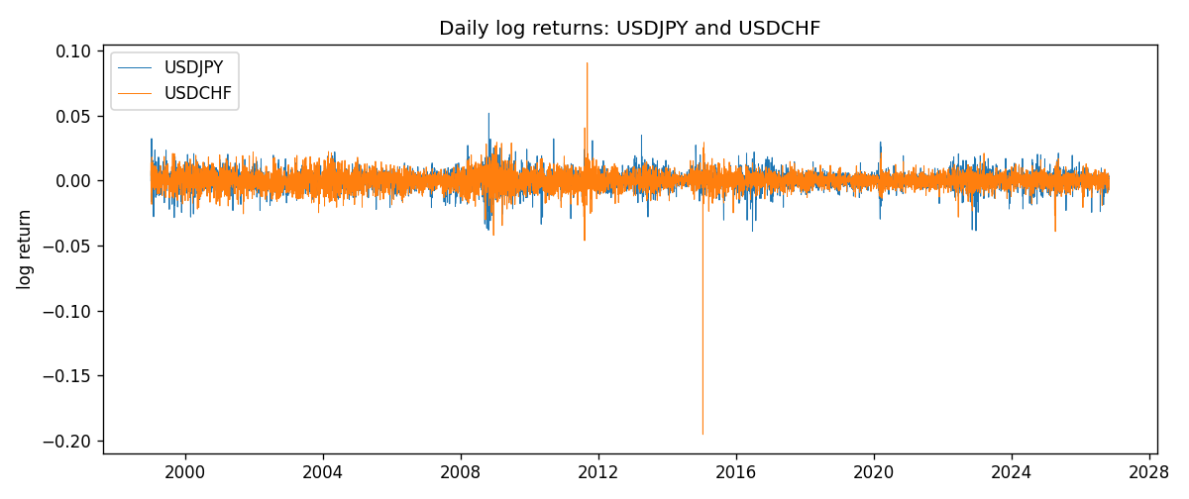
Log-return scatter
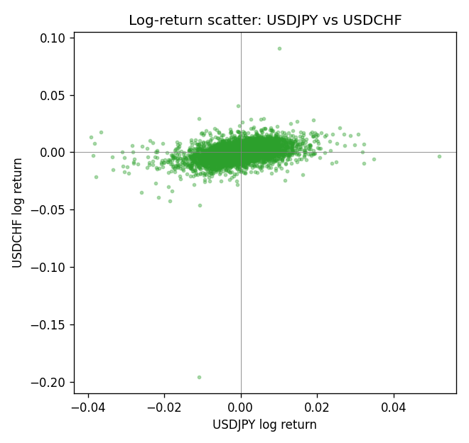
Rank-rank scatter
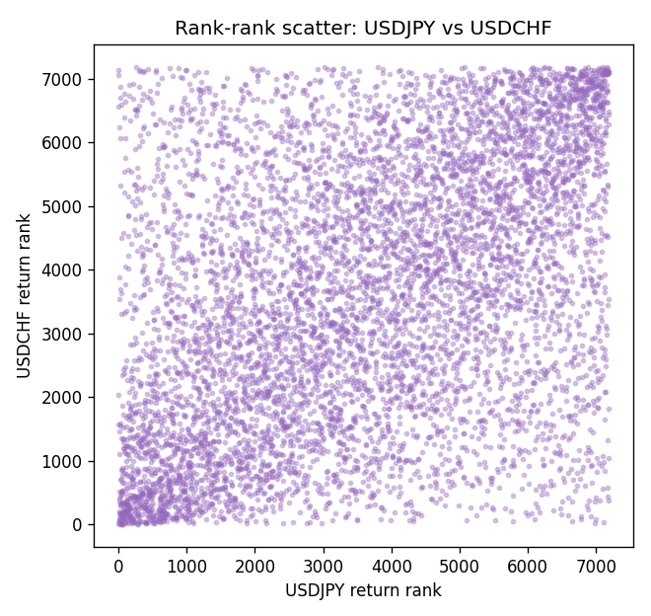

Data report
Every matched row that entered Spearman rho is stored in the sibling CSV named USDJPY-USDCHF_Spearman_D1.csv. That file is the complete data archive for redrawing charts. Embedding all rows as a Word table is impractical at this length; the Word file holds the column list, column summaries, and the first and last 15 matched rows.
Columns: time, USDJPY_open, USDCHF_open, USDJPY_high, USDCHF_high, USDJPY_low, USDCHF_low, USDJPY_close, USDCHF_close, USDJPY_tick_volume, USDCHF_tick_volume, USDJPY_spread, USDCHF_spread, USDJPY_real_volume, USDCHF_real_volume, USDJPY_log_return, USDCHF_log_return
Column summaries (matched calculation rows)
column | count | mean | std | min | 25% | 50% | 75% | max
USDJPY_open | 7185 | 113.80726 | 19.2236 | 75.693 | 104.38 | 110.984 | 120.69 | 163.824
USDCHF_open | 7185 | 1.0974395 | 0.25223318 | 0.72022 | 0.92053 | 0.98988 | 1.2375 | 1.8219
USDJPY_high | 7185 | 114.30433 | 19.285132 | 76.001 | 104.865 | 111.442 | 121.257 | 163.978
USDCHF_high | 7185 | 1.1027315 | 0.25397793 | 0.73305 | 0.92474 | 0.99353 | 1.2422 | 1.8313
USDJPY_low | 7185 | 113.28455 | 19.151449 | 75.402 | 103.87 | 110.53 | 120.17 | 163.628
USDCHF_low | 7185 | 1.0923205 | 0.25064913 | 0.08565 | 0.91719 | 0.98622 | 1.2315 | 1.8121
USDJPY_close | 7185 | 113.82023 | 19.238853 | 75.811 | 104.38 | 111.025 | 120.68 | 163.851
USDCHF_close | 7185 | 1.0974333 | 0.25214008 | 0.72025 | 0.92079 | 0.98995 | 1.2376 | 1.8217
USDJPY_tick_volume | 7185 | 106345.59 | 179437.4 | 149 | 9958 | 53202 | 92889 | 1803508
USDCHF_tick_volume | 7185 | 74334.331 | 113494.7 | 18 | 12809 | 40241 | 70443 | 858589
USDJPY_spread | 7185 | 20.263883 | 17.612444 | 0 | 6 | 11 | 30 | 50
USDCHF_spread | 7185 | 26.03215 | 24.694045 | 0 | 5 | 16 | 50 | 100
USDJPY_real_volume | 7185 | 3.4781051e+10 | 1.6093614e+11 | 0 | 0 | 0 | 0 | 3.8834203e+12
USDCHF_real_volume | 7185 | 2.3294091e+10 | 8.9133595e+10 | 0 | 0 | 0 | 0 | 1.9331921e+12
USDJPY_log_return | 7185 | 4.82e-05 | 0.00620617 | -0.03908203 | -0.00320044 | 0.00011473 | 0.00340924 | 0.05184024
USDCHF_log_return | 7185 | -6.962e-05 | 0.0065941 | -0.19545699 | -0.0033516 | 8.06e-05 | 0.00332472 | 0.09051364
First 15 matched rows (selected columns)
time | USDJPY_close | USDCHF_close | USDJPY_log_return | USDCHF_log_return | USDJPY_tick_volume | USDCHF_tick_volume
1999-01-05 | 111.92 | 1.3724 | -0.00017868311 | 0.0039424743 | 6367 | 4666
1999-01-06 | 112.77 | 1.3912 | 0.0075660159 | 0.013605652 | 6225 | 3740
1999-01-07 | 111.33 | 1.3782 | -0.012851583 | -0.0093883841 | 6671 | 4262
1999-01-08 | 110.8 | 1.3935 | -0.0047719894 | 0.011040268 | 10700 | 5991
1999-01-11 | 109.02 | 1.4009 | -0.016195423 | 0.0052963193 | 9168 | 5236
1999-01-12 | 112.6 | 1.3872 | 0.032310364 | -0.0098275602 | 10131 | 5975
1999-01-13 | 113.52 | 1.3621 | 0.0081373171 | -0.018259701 | 7265 | 7036
1999-01-14 | 113.52 | 1.3588 | 0 | -0.0024256692 | 6335 | 5825
1999-01-15 | 114.15 | 1.3834 | 0.0055343401 | 0.01794228 | 5479 | 7434
1999-01-18 | 114.16 | 1.379 | 8.7600193e-05 | -0.0031856384 | 5482 | 4965
1999-01-19 | 113.52 | 1.3789 | -0.0056219403 | -7.2518946e-05 | 5702 | 5494
1999-01-20 | 112.91 | 1.3889 | -0.0053879917 | 0.0072259871 | 5919 | 5477
1999-01-21 | 113.87 | 1.3836 | 0.0084664056 | -0.0038232689 | 6251 | 4736
1999-01-22 | 114.56 | 1.3834 | 0.0060412564 | -0.0001445609 | 5453 | 4833
1999-01-25 | 113.72 | 1.3868 | -0.0073594164 | 0.0024546976 | 4696 | 3996
Last 15 matched rows (selected columns)
time | USDJPY_close | USDCHF_close | USDJPY_log_return | USDCHF_log_return | USDJPY_tick_volume | USDCHF_tick_volume
2026-10-13 | 158.305 | 0.83244 | -0.0018932826 | -0.0024955621 | 81731 | 32763
2026-10-14 | 158.317 | 0.83489 | 7.5800166e-05 | 0.0029388325 | 95596 | 40903
2026-10-15 | 158.024 | 0.82676 | -0.0018524319 | -0.0097855323 | 115120 | 54132
2026-10-16 | 157.964 | 0.82377 | -0.00037976126 | -0.0036230826 | 86475 | 47176
2026-10-19 | 158.517 | 0.82677 | 0.0034946841 | 0.0036351779 | 70872 | 40610
2026-10-20 | 158.16 | 0.8246 | -0.0022546642 | -0.0026281224 | 82689 | 42106
2026-10-21 | 158.108 | 0.82427 | -0.00032883504 | -0.00040027413 | 67431 | 37648
2026-10-22 | 156.755 | 0.82032 | -0.0085942669 | -0.0048036381 | 100312 | 50809
2026-10-23 | 156.81 | 0.82497 | 0.00035080446 | 0.005652514 | 103374 | 45872
2026-10-26 | 157.458 | 0.82649 | 0.0041238746 | 0.0018407959 | 87120 | 41336
2026-10-27 | 157.894 | 0.82865 | 0.0027651658 | 0.0026100526 | 72962 | 35560
2026-10-28 | 157.743 | 0.82781 | -0.00095679538 | -0.0010142111 | 72076 | 42431
2026-10-29 | 157.683 | 0.82379 | -0.00038043789 | -0.0048680164 | 88229 | 53780
2026-10-30 | 157.516 | 0.82438 | -0.0010596481 | 0.00071594559 | 106706 | 55459
2026-11-02 | 157.933 | 0.81851 | 0.0026438521 | -0.0071459744 | 80702 | 45329

